Project Design Phase-II
Data Flow Diagram & User Stories
Date: 25 June 2025
Team ID : LTVIP2025TMID34216
Project Name :Clean Tech
Maximum Marks 4 Marks
Data Flow Diagrams:
A Data Flow Diagram (DFD) is a traditional visual representation of the information flows within a system. Below is the Level-1 DFD representation of the Clean Tech system, which highlights data collection from various waste sources, processing via transfer learning models, and storage/output to dashboards and databases.
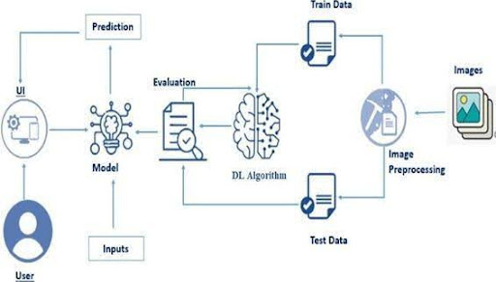

Level-1 DFD: Clean Tech System
Entities Involved:
- Waste Collection Units: Equipped with cameras to capture waste images.
- Edge Processing Unit: Classifies waste using a transfer learning-based model.
- Cloud Storage: Stores classified image data and logs.
- Monitoring Dashboard: Displays real-time analytics and classification results.
- Admin/User: Interacts with dashboard and manages data.
Data Flow Steps:
- Image Input: Waste images are captured by the collection units.
- Preprocessing: Images are cleaned and resized using OpenCV/PIL.
- Classification: Processed images are sent to the model (e.g., VGG16/MobileNet) for waste type classification.
- Storage: The results (label + confidence) are sent to cloud storage.
- Visualization: Dashboard fetches classification logs and shows analytics to users/admins.
- User Interaction: Admin can monitor waste trends, update model data, or download reports.

👥 User Stories
User Stories describe system functionality from the perspective of different users. These help in developing user-centered features and validating requirements.
🧍‍♂️ User Story 1: Waste Collector
- As a waste collector,
- I want to automatically classify and tag waste at the collection point,
- So that I can ensure proper segregation without manual sorting.
🧍‍♀️ User Story 2: System Administrator
- As an admin,
- I want to monitor the classification accuracy and update the model when needed,
- So that the system stays reliable and up-to-date with changing waste patterns.
👨‍💻 User Story 3: Data Analyst
- As a data analyst,
- I want to access historical classification logs and reports,
- So that I can analyze trends in waste generation and inform sustainability initiatives.
🧑‍🎓 User Story 4: Developer
- As a developer,
- I want to deploy and test transfer learning models on edge devices,
- So that I can ensure efficient performance in real-time classification.
🧑‍🔧 User Story 5: City Waste Manager
- As a city waste manager,
- I want to receive alerts when bins are full or misclassification happens,
- So that I can optimize waste collection routes and reduce operational costs.

